Zsnaps
What is a Zsnap?
- A Zsnap is a “zip” file with information about the grade system
  - Captures CAN and Ethernet communication
  - Address claims
  - Sensor Logs
  - Machine Dimensions
  - System diagnostics
- Zsnaps require special program to “unzip” them
- Typically captures last 5 minutes of operation
- For sensor connectivity issues
  - Press recheck in diagnostics and wait 15-20 seconds before taking zsnap
Zsnap Recommendations
- Take a zsnap of new installs operating properly
  - Diagnostic.txt file contains useful information
  - Keep with machine installation records
  - Use for future troubleshooting
    - New installs on other machines
    - Current issues on the same machine
    - Send to support with zsnap showing issue
- ZSnaps include additional info when taken in the Operator Interface
  - Includes Android log for app crashes
  - Screenshots displayed screen when ZSnap taken
How to Take a Zsnap
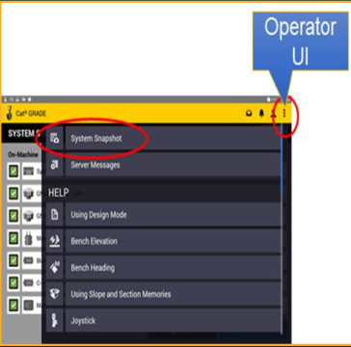
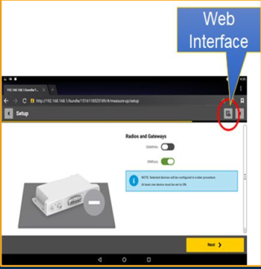
Downloading Zsnaps
- Zsnaps sync to the Earthworks Data folder after a USB sync
- You can download from Web Interface
  - Home>System Snapshot
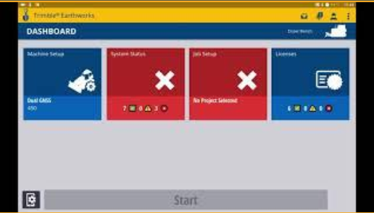
What is in a Zsnap?
- Dealers are able to access the following:
  - *.zsnap (unreadable)
  - Diagnostics.txt
  - Screen capture
- *.zsnap includes the Diagnostics and screen capture, only need to provide *.zsnap to support
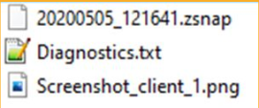
What is in the Diagnostics.txt?
- Useful information in the diagnostics.txt file
  - System Information
  - Licenses installed
  - Machine info (what’s installed, fw versions)
  - Machine status
  - Measure-up values, dimensions, and valve cal table
  - Coordinates of blade tip with focus
  - Radio settings
  - GNSS diagnostics (no logs)
- Primary Earthworks diagnostics file containing information about the EC520 hardware, operating system running on the EC520, software running on the EC520, and state of the machine and sensors. This is usually the first place to look when diagnosing problems.
